MODULE ONE
A PERFECT STORM: THE REALITY OF THE ECOLOGICAL CRISIS

THE NEW ZEALAND SITUATION
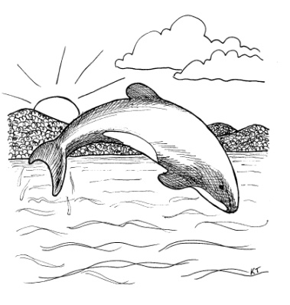
4 MAJOR PROBLEMS

B_______________________ Loss

H________________________ Destruction

I Species

O_________________________ Complacency

THE GLOBAL SITUATION

4 MAJOR CATEGORIES OF PROBLEMS

DESTRUCTION OR LOSSES OF N________________ RESOURCES
- Habitats (such as forests, wetlands, and coral reefs)
- Wild Foods, especially fish and shellfish
- Biodiversity (we are already witnessing the sixth and most catastrophic global wave of extinctions)
- Soil (which is being destroyed far more quickly than it is being formed)

C___________________ ON NATURAL RESOURCES
- Energy - coal, oil, natural gas
- Freshwater - most of what is available is already being utilized.
- Photosynthetic Capacity (the amount of solar energy fixed by photosynthesis)
All of these are finite and will very soon reach their limit.

H___________________THINGS THAT WE PRODUCE OR MOVE AROUND
- Toxic Chemicals - insecticides, pesticides, herbicides, detergents, plastics, etc.
- Alien Species - some useful but others are hugely devastating
- Atmospheric gases - which damage the protective ozone layer or absorb sunlight and thereby lead to global warming.

P____________________ ISSUES
- Population Growth (especially the disproportionate number of children and young reproductive people)
- The Impact of that Growth on the environment as so many seek a better standard of living (which the planet can't sustain)

QUESTIONS TO PONDER

Take five minutes to personally consider these questions...

- Is the claim that NZ is 100% pure true? If not, what percentage would you use?

20% _____ 40% _____ 60% _____ 80% _____ 100% _____

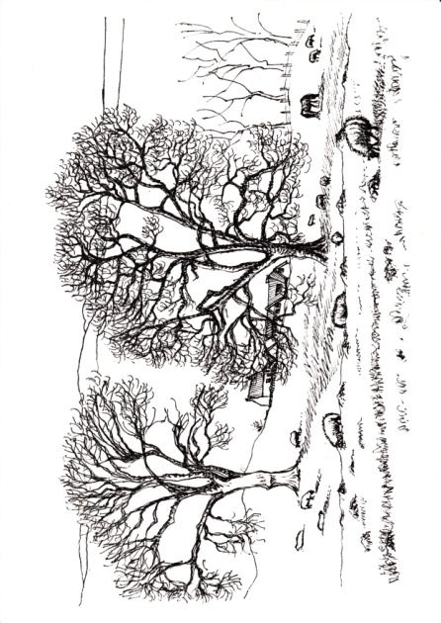
- What in your opinion, what is the single biggest environmental problem the world faces at this time? Circle ONE of the following:

Global warming/Climate change
Energy problems
Pollution (air, water, etc))
Toxic substances in environment
Loss of habitat/Overdevelopment
Biodiversity loss
Waste disposal
Other
None
Unsure

- Do you think that global warming will pose a serious threat to you or your way of life in your lifetime?

Yes: _____ No: _____ Unsure: _____

- Which do you think would do a better job reducing global warming: the government, through laws intended to reduce the output of greenhouse gases, or businesses, through competition in the market system?

Government _____ Business _____ Both Equally _____ Unsure _____

- Should polluters pay for the damage they cause (e.g. a carbon tax)?

MODULE TWO
IMPERATIVES AND INSPIRATION:
THE BIBLICAL MANDATE FOR CREATION CARE

As Christians, any course of action we take should be sanctioned by the Bible. Here are 7 big ideas…

- S________________________ Genesis 1:28-30, 2:15.

- S________________________ Psalm 19:1-6, Romans 1:20.

- S________________________ Deuteronomy 20:19,22:6-7; Exodus 20:8-11, 23:10-12; Leviticus 22:28,25:1-54; Psalm 45:17, 71:18, 78:4, 89:1.

- S________________________ John 1:3; Colossians 1:15-20; Hebrews 1:2-3; Romans 8:29; I John 4:17.

- S________________________ Psalm 29:1-2; John 4:23; I Chronicles 16:29-34; Nehemiah 9:6; Psalm 1:8-9; Isaiah 55:12-13; Revelation 5:13.

- S________________________ Genesis 6-9; Acts 3:21; Romans 8:18-25; Ephesians 1:10; Colossians 1:20; Revelation 21:5.

- S________________________ I Chronicles 12:32; Ephesians 5:16.

Caring for creation is one of the key responsibilities that God has given us.
It is mentioned throughout the Bible. Indeed, it is a pervasive theme.
QUESTIONS TO PONDER

In your group:

- Which one of the seven ideas do you find most convincing and cogent? Which one speaks to you most strongly? Share your choice. Discuss.

Individually:

- The custody of the garden was given to Adam, to show that we possess the things which God has committed to our hands, on the condition that, being content with the frugal and moderate use of them, we should take care of what shall remain.
- John Calvin, Commentary on Genesis

Have recent generations been "content with the frugal and moderate use" of the earth's resources? Give examples.

- If you believe in an all-powerful God, maybe you should ask yourself this question: Why was I born here? Why wasn't I just born in heaven?
Why were you born on earth rather than in heaven?

- 'To dress and keep it'
That, then, was to be our work.
Alas! What work have we set ourselves instead?
How have we ravaged the garden instead of kept it?
- John Ruskin

In our commerce and workplaces, how have we "ravaged the garden"? Give examples.

MODULE THREE
AN INCONVENIENT TRUTH:
OCCASIONAL OBJECTIONS AND EVERYDAY EXCUSES

Always be prepared to give an answer to everyone who asks you to give a reason for the hope that you have. But do this with gentleness and respect…
I Peter 3:15

Isn’t God going to destroy this earth anyway? If this present earth is going to be destroyed eventually (2 Peter 3:10-13) what is the point of our taking care of it now? Why get sentimental about a container that served its purpose and is about to be completely replaced ? Why bother?

EXERCISE: In your group, consider how you would answer the objection/excuse allocated to your group. Appoint a notetaker/spokesperson who can BRIEFLY report back your ideas.

Isn't this business about ‘saving the earth’ a distraction to the church’s task of ‘saving souls’? Shouldn’t we just be focusing on evangelism rather than worrying about the planet?

It is God’s job, not ours, to care for the planet. After all, God made the earth and it’s his responsibility to preserve it. Since God is in control, shouldn’t we just stand back and let him do whatever he is going to do. It’s his problem – let him take care of it.

Shouldn't we spend our time and resources helping poor people rather than animals or plants?

What’s the point? The ecological problems are so big. What I do won't make any difference.

Science and green technology will save us. And anyway, it's up to the government to protect us.

Since we’re headed for heaven anyway, why take care of creation? Why bother since we'll be whisked away safely in our spirits from this God-forsaken physical planet?

We don’t need to worry about nature. Everything will be renewed after the rapture.

Ecology and environmental issues are a bit dodgy because the green movement has been infiltrated by New Age thinking, so Christians should keep well clear.

There are too many worldly people out there doing environmental things.

We need to avoid anything that looks like political correctness.
Respecting creation gets us too close to pantheism. Tree huggers worship nature. I don’t want to be involved with them.

Caring for creation will lead to world government.

Before you know it, we’ll have to support abortion.

God told us to ‘fill the earth and subdue it’ and to ‘have dominion’ over it. So aren’t the earth and its creatures simply there for our use and enjoyment?

Wealth is God’s reward to believers.

I bought my SUV because it is bigger, weighs more, sits up higher, and is safer in a crash. If I’m going to be in a wreck, I want my family to be safe.

I don’t have time to worry about the world’s problems.

Haven’t Christians got an appalling track record in caring for creation, and isn’t that all based on what the Bible teaches?

Isn’t the gospel about spiritual, not material matters? Doesn’t God care about our souls, not our bodies? Shouldn’t our minds be on heaven and not on earth?

Looking after the environment is fine if that’s your thing, but it isn’t for everybody. I’m glad somebody’s caring for the planet, just as long as it doesn’t have to be me!
There’s no urgency. We’ve got plenty of time. These problems won’t become serious until after I die, or even later.

My neighbours all do it. Why shouldn’t I?

I don’t want to be an alarmist or extremist.

I disagree with what some environmentalists and scientists say will happen.

Why a Christian environmental organization? Shouldn’t we just join with others?

QUESTIONS TO PONDER

- Have you used any of these objections/excuses yourself?

- If so, do you still think the same, or have you changed your mind?

AN INTERESTING POSTSCRIPT

According to Yale University's Cultural Cognition Project, one's "cultural worldview" (= political leanings, ideological outlook) explains individuals' beliefs about climate change more powerfully than any other characteristic.

The Yale researchers explain that people with strong "egalitarian" and "communitarian" worldviews (marked by an inclination towards collective action and social justice, concern about inequality, and suspicion of corporate power) overwhelmingly accept the scientific consensus on climate change. Conversely, those with strong "hierarchical" and "individualistic" worldviews (marked by opposition to government assistance for the poor and minorities, strong support for business and industry, and a belief that we all pretty much get what we deserve) overwhelmingly reject the scientific consensus.

What the latter group care about is exposing climate change as a "hoax" perpetrated by liberals to force them to change their light bulbs, live in Soviet-style tenements, and surrender their SUVs. They deny reality because the implications of that reality are, quite simply unthinkable...

We do know that having a significant stake in the fossil fuel industry makes one more prone to deny the reality of climate change, regardless of political affiliation.

The bottom line is that we are all inclined to denial when the truth is too costly - whether emotionally, intellectually or financially.

One of the more interesting findings of many recent studies on climate change perceptions is the clear connection between a refusal to accept the science...and social and economic privilege. Overwhelmingly, climate change deniers are not only conservative but also white and male, a group with higher than average incomes.

See Naomi Klein, 2014: This Changes Everything, pp.36-37,43, 45-46

To the extent people prioritize values and goals such as achievement, money, power, status and image, they tend to hold more negative views towards the environment, are less likely to engage in positive environmental behaviours, and are more likely to use natural resources unsustainably.

Tim Kasser and Tom Crompton, 2009: Meeting Environmental Challenges: The Role of Human Identity, p.10

I have heard every kind of objection and rationalization for not protecting our earthly ark of life. Most of the arguments boil down to selfishness. I have met those who would bet the futures of their grandchildren on wishful thinking that the earth will end tomorrow; however, I’ve met none willing to bet their 401Ks on such end-time thinking.
- Matthew Sleeth, The Green Bible, 2008: p.I-22

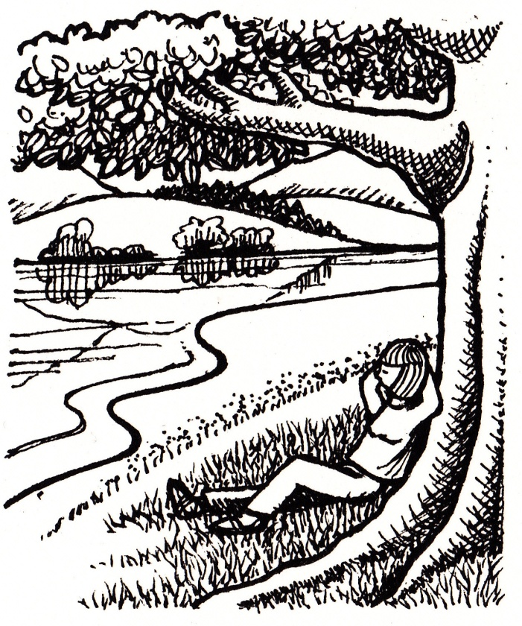

MODULE FOUR
FOR HEAVEN'S SAKE: CREATION CARE AS A MATTER OF
MORALITY AND AS A MEANS OF MISSION

In this module we are looking at two aspects: creation care as a matter of morality and as a means of mission. Morality and mission are both pursued "for heaven's sake". i.e. to better reflect and advance the kingdom of God.

A MATTER OF MORALITY

MORAL OR AMORAL?

Is the environment and how we treat it something to which notions of morality are relevant and can be legitimately applied?

...climate change will test our moral character like little before.
Naomi Klein, 2014: This Changes Everything, p.48

It is not right for us to destroy the world God has given us. He has created everything; as the Bible says, 'The God who made the world and everything in it is the Lord of heaven' (Acts 17:24). To drive to extinction something He has created is wrong. He has a purpose for everything...
Billy Graham, Detroit Free Press

Science alone will not be able to resolve the situation because it is a moral, spiritual and ethical one requiring major changes in our behaviour.
Sir Ghillean Prance (former Director of the Royal Botanic Gardens at Kew)

MORAL RESPONSIBILITY/OBLIGATION TO ANYONE OR NOT?

When it comes to the environment and how we treat it, do we have a moral obligation towards anyone?

ACCOUNTABLE OR NOT ACCOUNTABLE?

Are we as individuals responsible and accountable for acting in an environmentally destructive way in a backward-looking sense?

Are we as individuals responsible for acting in an environmentally destructive way in a forward-looking sense?
ANTHROPOCENTRIC OR BIOCENTRIC?

To understand Christian environmental ethics, we need to differentiate between two opposite perspectives which affect the way people relate to the environment...

- Anthropocentric (Humans at the centre of concern. Only humans have intrinsic value, therefore human interests should come first)
Arguments:
1. Nature is for people
2. Human interests are more important than environmental ones
3. Human interests produce good environmental policies

- Biocentric (The environment at the centre of concern. The environment has value in and of itself and we should act in its best interests rather than our own).
Arguments:
1. Living things have an independent moral standing
2. Humans are part of a larger natural process
3. Environmental responsibility is best served through governmental regulation

- Arising out of biocentrism, some have put forward a third ethical perspective:
Ecocentrism: whole ecological systems have intrinsic value (incorporating human and non-human elements). It is a holistic view that preserves connections.

Question: Which ethnic/socio-economic groups in NZ are more likely to lean towards one of these positions?

WHAT PRINCIPLES CAN WE APPLY IN MORAL REASONING ABOUT THE ENVIRONMENT?

Justice and Sustainability
To apply justice to an environmental decision, we should ask:

- Are all human beings involved in this situation being treated equally and, if not, why not?
- Are all living creatures involved in this situation being treated equally and, if not, why not?
To apply the principle of sustainability to an environmental decision, we should ask:

- What are the immediate and long-term effects of the problem before us?
- Who - humans and otherwise - is affected today by the problem before us and who will likely be affected by this problem in the future?
Sufficiency and Compassion
To apply the principle of sufficiency to an environmental decision, we should ask:
- Will the decision permit all those involved, especially the poor, to have enough resources on which to live and flourish?
- Is there any aspect of the decision that indicates the presence of waste or excess? Or a failure to be creative?

To apply the principle of compassion to an environmental decision, we should ask:
- What duties do we have to the other creatures likely to be affected by our actions?
- What does sufficiency mean for other creatures, especially those threatened with extinction?
- What would it mean to extend the principle of compassion to non-human creatures?
Solidarity and Participation
To apply the principle of solidarity to an environmental decision, we should ask:
- Who are all the human stakeholders involved in this situation?
- Who are all the natural stakeholders?
- Is there a community of life (ecosystem) involved?
- Are there any stakeholders - human and non-human - who are especially vulnerable?
To apply the principle of participation to an environmental decision, we should ask:
- Do all stakeholders in this decision actually have a say in how the decision is going to be made?
- Are there any stakeholders who cannot represent themselves? Or who have little power? How will their interests be represented in the decision-making process?
Modes of Ethical Reasoning about the Environment
C____________________________________________

C____________________________________________

C____________________________________________

QUESTIONS TO PONDER

1. In his book The Great Divorce, C. S. Lewis depicts hell as a place of infinite resources.
How can unlimited resources - what most would consider a blessing - lead to undesirable behaviours and outcomes.? Give examples.

2. How does our culture's focus on wealth and independence pull us away from interdependence and sharing?
A MEANS OF MISSION

Mission is a word often used but it is not easy to find a concise definition which describes it, even less to find one on which everyone can agree. Mission has many elements to it, which is reflected in the widely used ‘Five Marks of Mission’ formulated by the Anglican Church:

1. Anglican Consultative Council (one of the authoritative international bodies of the Anglican Communion)
‘To proclaim the Good News of the Kingdom
To teach, baptise and nurture new believers
To respond to human need by living service
To seek to transform unjust structures of society, to challenge violence of every kind and to pursue peace and reconciliation
To strive to safeguard the integrity of creation and sustain and renew the life of the earth.’
(Bonds of Affection-1984 ACC-6 p49. Mission in a Broken World-1990 ACC-8 p10 and ACC Auckland 2012)

2. The Constitution of the Anglican Church in Aotearoa New Zealand and Polynesia
(from the Preambles):
...the mission of the Church includes:
(a) proclaiming the Gospel of Jesus Christ,
(b) teaching, baptising and nurturing believers within eucharistic communities of faith,
(c) responding to human needs by loving service and
(d) seeking to transform unjust structures of society, caring for God’s creation, and establishing the values of the Kingdom.

You will notice that the statements above refer to striving to "safeguard the integrity of creation and sustain and renew the life of the earth" and "Caring for God's creation."

The language of the Anglican ‘Mission Shaped Church’ Report reflects this, describing mission as:
“God’s missionary purposes are cosmic in scope, concerned with the restoration of all things, the establishment of shalom, the renewal of creation and the coming of the kingdom as well as the redemption of fallen humanity and the building of the Church.”

There are many, of course, who think that we should concentrate on saving souls and forget about saving seals, but (as we learned in Module 3) it is not a case of either/or; it is a case of both/and. God wants to rescue both the human and the non-human creation. Both lie within the scope of his redemptive purposes.

The Old Testament views future salvation as restoration of life in creation, and Jesus affirms the Old Testament view of salvation in his kingdom mission. He told us to “Go into all the world and proclaim the good news to the whole creation." (Mark 16:15 NRSV). Caring for what God has made is cooperating with him in part of his mission.

What A Rocha says is that we should engage in caring for the non-human creation as a witness and relationship bridge to the human creation, and also as a way of increasing the wellbeing of both.

BUILDING RELATIONSHIPS WITH NON-BELIEVERS

It has long been recognised that the key requirement for successful evangelism is to build bridges into the community and form relationships with people who have not yet come to faith. After all, you cannot influence anyone towards anything if you do not connect with them.

This awareness was given impetus by research done by Ray Muller in NZ in the 1990s (detailed in the book New Vision New Zealand, Volume 1, chapter 12). He surveyed how people come to Christ and the Church. This is what he discovered:

MEANS (PRIMARY INFLUENCE) | PERCENTAGE RANGE
Special need
Walk-in
Pastor or church staff
Visitation/telemarketing
Sunday School/Small group
Evangelistic crusade
Church programmes
Friends and/or relatives

Today, many people are seeking spiritual reality but see Christianity as irrelevant to the questions they are asking. Creation is a place where they encounter something of that spiritual reality, sensing a greater presence, experiencing the ordering of seasons and tides, or feeling a deep empathy with other creatures. Sadly, Christians have often dismissed such experiences as nature worship. Yet surely this is exactly what Romans 1:20 means by seeing God’s invisible qualities through what has been made. Creation is a natural place of encounter with God. What a tragedy that those struggling to make sense of God’s fingerprints in creation often find Christians closing the door in their faces.

The environmental movement today certainly includes people with a very different view of the world from Christianity, but also many who are openly searching for spiritual reality. Citizens of the kingdom of God yearn for shalom, but non-Christians often yearn for it too, and sometimes work so tirelessly for this that they put Christians to shame. It’s a compelling reason for Christians to get involved.

Creation care furnishes an immediate point of mutual interest, shared vision, identification and commonality. It also provides a context in which to forge meaningful relationships as a prelude to evangelistic influence. For this reason, Christian environmentalism is currently one of the fastest growing and most productive missional enterprises in the global church.
For instance, A Rocha took a piece of unkempt land in West London and turned it into an oasis for wildlife called Minet Country Park. It raised questions among the neighboring people, “Why are they doing this?” It gave opportunities for them to find out that their ecology was based on the gospel and their gospel was centred on the Lord Jesus Christ.

ENVIRONMENTAL MISSION - A NEW FRONTIER

Between 29 October and 2 November, 2012 a very significant and timely event took place in Jamaica. The Lausanne Movement for Global Evangelisation, in collaboration with the World Evangelical Alliance, held its first ever Consultation on Creation Care and the Gospel. It was a gathering of theologians, church leaders, scientists and creation care practitioners, fifty-seven men and women from twenty-six countries from the Caribbean, Africa, Asia, Latin America, Oceania, North America and Europe.

The days of discussion and deliberation arrived at two primary convictions. The first was that creation care is indeed a gospel issue within the lordship of Christ. The second was that we are faced with a crisis that is pressing, urgent, and that must be resolved in our generation.

These two convictions were given practical expression in a 10-point Call to Action. It called the whole church, in dependence on the Holy Spirit, to respond radically and faithfully to care for God’s creation, demonstrating its belief and hope in the transforming power of Christ.

Of particular interest was the highlighting of a new frontier of mission. The delegates agreed that “environmental issues represent one of the greatest opportunities to demonstrate the love of Christ and plant churches in our generation”. They encouraged the church to promote “environmental missions” as a new category within mission work (akin in function to medical missions).

QUESTIONS TO PONDER

- How would you begin to define ‘mission’? What is 'mission' in a Christian context?
- How does thinking of the Church being partners with God in his mission affect your own understanding of mission?
- Is rescuing the non-human creation part of the church's mission?
- Most people prefer to emphasise some of the Marks of Mission, more than others – which ones naturally appeal to you? And how can we engage in those which don’t come so naturally to us?
- How can the local church use creation care to establish and build relationships with non-believers?
- Do you agree with the Lausanne movement's recognition of "environmental mission" as a new frontier of mission?
- What kind of EM project could your church initiate (in NZ and/or overseas)?
MODULE FIVE
FOR SUCH A TIME AS THIS: TRANSLATING THEORY INTO PRACTICE

We need to remember that the work of our time is much bigger than climate change. We need to be setting our sights higher and deeper. What we are really talking about, if we're honest with ourselves, is transforming everything about the way we live on this planet.
- Rebecca Tarbottom, Executive Director of the Rainforest Action Network, 1973-2012, http://ran.org/becky

If we would call 111 to save a life, why aren't we (metaphorically) calling 111 to save all life?
Matthew Sleeth, 2010: Hope for Humanity, p.105

TWO OBJECTIONS

Looking after the environment is fine if that’s your thing, but it isn’t for everybody. I’m glad somebody’s caring for the planet, just as long as it doesn’t have to be me!

What’s the point? The ecological problems are so big. What I do won't make any difference.”

See Module 3: Objections and Excuses

KEY CONSIDERATIONS

- Time is _________________

- Climate change is an opportunity for c_________________ on big scale

- Minor tweaking and incremental change will not now be e______________

- We cannot rely on p___________________ leaders

- A grass roots m________________________ of unprecedented proportions is needed

- F__________________ generations will be affected by what we do or don't do now

TWO OPTIONS

1. Do nothing
We know that if we continue down our current path of allowing emissions to rise year after year, climate change will change everything about our world. Major cities will very likely drown, ancient cultures will be swallowed by the seas, and there is a very high chance that our children will spend a great deal of their lives fleeing and recovering from vicious storms and extreme droughts. And we don't have to do anything to bring about this future. All we have to do is nothing. Just continue to do what we are doing now, whether it's counting on a techno-fix or tending to our gardens or telling ourselves we're unfortunately too busy to deal with it.

All we have to do is not react as though this is a full-blown crisis. All we have to do is deny how frightened we really are. And then, bit by bit, we will have arrived at the place we most fear, the thing from which we have been averting our eyes. No additional effort is required.
Naomi Klein, 2014: This Changes Everything, p.4

Remember what Edmund Burke said: “All that is needed for the triumph of evil is that good people do nothing”.

2. Take action
We cannot avoid the conclusion that caring for what God has made is a significant theological vision in the Bible. But knowing that is not enough. If any context in which we are exposed to truth does not become a laboratory for life transformation, the Bible is not fulfilling its God-intended function in our lives. Knowledge must issue in actions. We must be doers and not just hearers (James 1: 22-25). I believe we must be utterly realistic, acknowledging the disturbing challenges that confront us. We cannot afford to press the snooze button, roll over and go back to sleep. Nor should we be presumptuous, expecting God to save us from our folly. It’s up to us to begin to remedy our ways, because doing what is right and responding to the Spirit of God is important and valuable at every point in our lives.
- Phillip Donnell

To serve as custodians of creation is not an empty title; it requires that we act, and with all the synergy this dire situation demands.'
Desmond Tutu, 'We Need an Apartheid-Style Boycott to Save the Planet', Guardian, 10 April, 2014.

We need to re-think what really matters. Christians have a crucial role to play in this process. But to do so the Church itself must be reformed; in particular, it needs an ecological reformation. Christians need a stronger and more compelling theology of ecological responsibility and resilience, and they need to practise what they preach. The care and integrity of creation must become a key priority, not merely an optional extra. There is a long and difficult journey ahead, but precious little time.
- Professor Jonathan Boston, Victoria University, speaking at the A Rocha national conference "Christianity and the Ecological Crisis: Lament, Hope, Action", Wellington, October, 2012
Matthew Sleeth uses the Parable of the Good Samaritan (Luke 10: 25-37) to identify three possible responses. He writes:

This parable demonstrates a continuum of compassion, which can be applied to many problems, including the environment. The priest represents those of us who refuse to take any responsibility for environmental problems, even though we claim a close relationship with God. We close our eyes and walk on by. The second passerby, the Levite, is like most of us: he sees the problem, then says, "I should get back to Jerusalem and raise awareness. Maybe I'll blog on the problem of highway muggings, or send a letter off to the Roman centurion about beefing up patrols and installing better street lights." Like the Levite, we see the hardship caused by environmental problems, particularly for the poorest among us. Our hearts are moved to compassion, but we do little, if anything, to help because we don't want to be inconvenienced. Only the Samaritan, the one who is least likely to view the fallen Jewish man as his neighbour, takes action .He saw the need, and had mercy on him. Jesus tells us, as he told his questioner, "Go and do likewise."

What does this parable teach us about how we should approach environmental problems today? To have any lasting effect, our hearts must be moved by compassion for our fellow man and all of God's creation...

Everyone is our neighbour, including foreigners, strangers, people who hate us, and future generations. Perhaps the most important lesson of the Good Samaritan - the action that can separate us from the priest and Levite - is that we must "get off our donkey" before we can become part of the solution. The future will not be saved by our good intentions. It will be made better or worse, only by our actions.
(2010: Hope for Humanity, p.108-109)

Question:
Environmentally speaking, are you a priest, a Levite, or a Good Samaritan?

TAKING ACTION

- Reconnect with n______________________ and find joy in it!
- Reduce c_____________________________

- Make better (informed) c_______________

- Resist the production of, and minimise the use of, f__________ f_________

- Get i___________________ in environmental projects (and stir your church to do so!)

- Put pressure on, and pray for, l________________

- Adopt and articulate a different w___________________

- Challenge current e________________paradigms

- Maintain your optimism and h___________ in God

QUESTIONS TO PONDER

- We Christians have a responsibility to take the lead in caring for the earth.
- Billy Graham, Detroit Free Press
How can Christians take a lead role in "caring for the earth"?

- If we are ever able to stop destroying our environment, it will be because person by person we decide, by God's grace, to turn aside from greed and materialism. It will be because we learn that joy and fulfilment come through right relationship with God, neighbour and earth, not an ever-escalating demand for more and more material consumption. Nowhere is that more possible than in local congregations that combine prayer and action, worship and analysis, deep personal love for the Creator and for the Creator's garden
- Dr Ronald Sider, Professor of Theology and Society, Eastern Baptist Theological Seminary
How can a church foster "love for the Creator and for the Creator's garden"? How can the church help us "turn aside from greed and materialism" and pursue a "right relationship with God, neighbour and earth"? What has your church done to foster and pass along a love for God's creation?
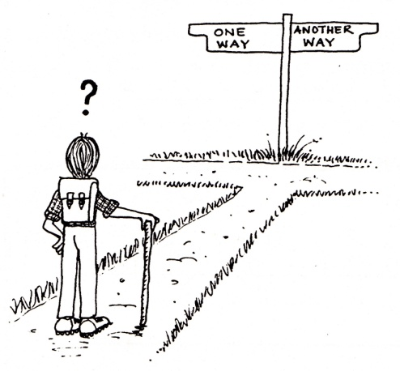

Today history has knocked at your door. How will you answer?

Many of the world’s poorest people, ecosystems, and species of flora and fauna are being devastated by violence against the environment in multiple ways, of which global climate change, deforestation, biodiversity loss, water stress, and pollution are but a part. We can no longer afford complacency and endless debate. Love for God, our neighbours and the wider creation, as well as our passion for justice, compel us to urgent and prophetic ecological responsibility.

STEWARDSHIP ACTION PLAN

The test of a preacher is that his congregation goes away saying, not “What a lovely sermon!” but, “I will do something!”
- Francis de Sales

Does God give us truth simply for truths sake - just to tickle our ears?
No. He gives us truth in order that we might apply it, work it out in practice.
The fact is that many Christians are filled to the brim with unapplied truth.
If we only applied 20% of the truth we already know, we would be much the better for it and so would the world as a whole! Truth must issue in life transformation. Change! Action!

I don't know about you, but I cannot work on multiple changes at once in my life.
I need God to make me aware of just one thing, and let me concentrate on changing just that. Paul recognised that this was true for him as well. At one point in his life, maybe God made him aware that his Christian life and ministry was a bit static, in the doldrums, that he was not progressing in the fulfilment of his calling and his commission. Maybe the devil reminded him of his past, so he thought he was unworthy to serve and things just ground to a halt. So at that point he wrote to the Philippians (in the context of talking about moving forward):
“This one thing I do…” (Philippians 3:13)

What is one thing you can do within the next 3 months in terms of environmental stewardship? That one thing should be personal, practical and specific. Write it here, then share it with your group (or if you prefer not to, just say "Pass"):

____________________________________________________________________________________________________________________________________________________________________________________________________________________________________________________________________________________________________________

Do you consider yourself an environmentalist or not?
Yes: _____ No: _____ Unsure: _____

The changes we make will not earn our way to heaven, but they do two important things for our souls: they connect us with the family of humanity around the globe, and, more importantly, they bring us closer to God. If he asks us to give up everything we have and follow him, I now know with certainty that each member of my family would gladly do so. This lack of attachment to things brings us priceless freedom and allows us to hear his call.
-Matthew Sleeth, 2010: Hope for Creation, p.105

