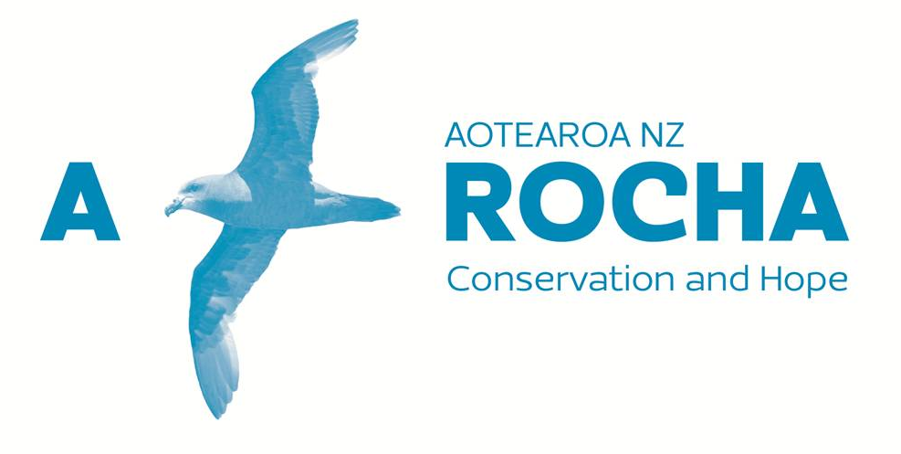

WELCOME TO

PLANETCARERS
a seminar exploring why Christians need to be
actively involved in environmental stewardship

FIVE MODULES
10.15 - 11.15 a.m.
MODULE ONE: A PERFECT STORM
The Reality of the Ecological Crisis (nationally and globally)
11.30 a.m. - 12.30 p.m.
MODULE TWO: IMPERATIVES AND INSIGHTS
The Biblical Mandate for Creation Care (seven significant signals)
LUNCH
1.15 - 2.15 p.m.
MODULE THREE: AN INCONVENIENT TRUTH
Occasional Objections and Everyday Excuses (addressing the hang-ups)
2.30 - 3.30 p.m.
MODULE FOUR: FOR HEAVEN’S SAKE!
Twin Transformations (creation care as a matter of morality and a means of mission)
AFTERNOON TEA
4.00 - 5.00 p.m.
MODULE FIVE: FOR SUCH A TIME AS THIS
Translating Theory Into Practice (answering the “So what?” question)

Presented by Phillip Donnell
(A Rocha Aotearoa New Zealand / Planetcarers International)
Note:

This folder contains only outlines of the content of each module.

If you would like a copy of the full script of any module to be emailed to you, please write your details on the list on the table. A hard copy is there for you to peruse, but please do not take it away.

Similarly, if you would like a copy of the Powerpoint slides of any module to be emailed to you, write your details on the list. A hard copy of the slides is there for you to peruse, but please do not take it away.

Electronic means are being employed in this way to reduce the use of paper and thereby assist the planet!

********************************************************

Phillip is happy to faciliate this seminar, or any part of it, in any context by mutual arrangement.

Contact him at: pjdonnell@orcon.net.nz;
phillip.donnell@arocha.org

********************************************************

A selection of food and drink is available from the outlets in the Windsor Park shopping centre and the Windsor Park Centre cafe.
Feel free to utilise these during the lunch and afternoon tea breaks.

********************************************************

ENJOY YOUR DAY!

